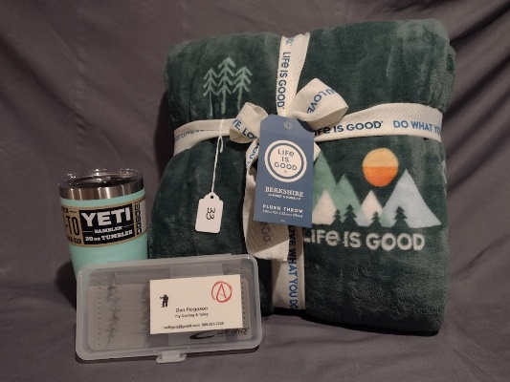

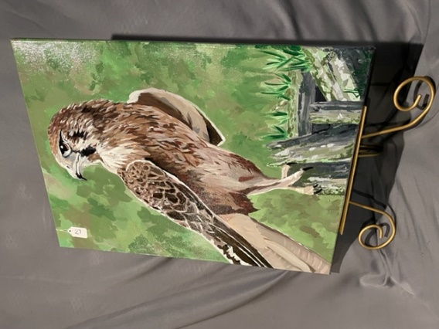

These are examples of procurement baskets from Auction 2022. Families can make their own themed basket or turn in individual items and the auction team will put a basket together with similar items.